WEEK - 12

WEEK – 12 USER DEFINED FUNCTIONS REg NO : 240901065

# NAME : NETHRA P Q1)

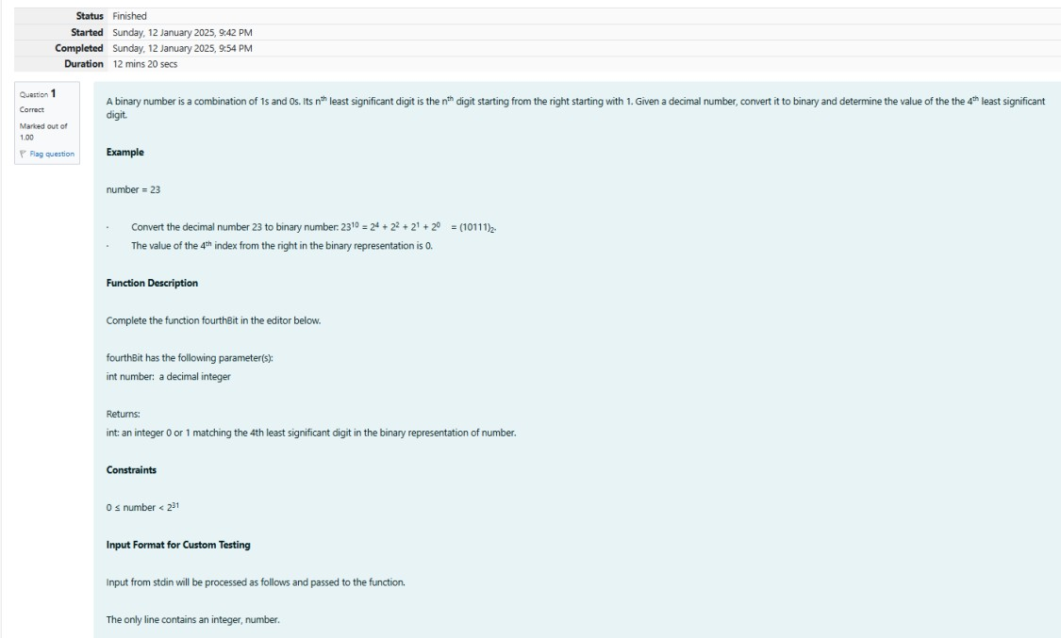

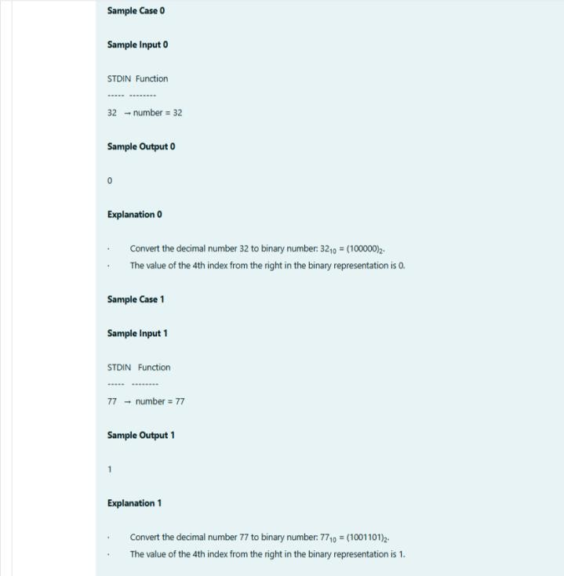

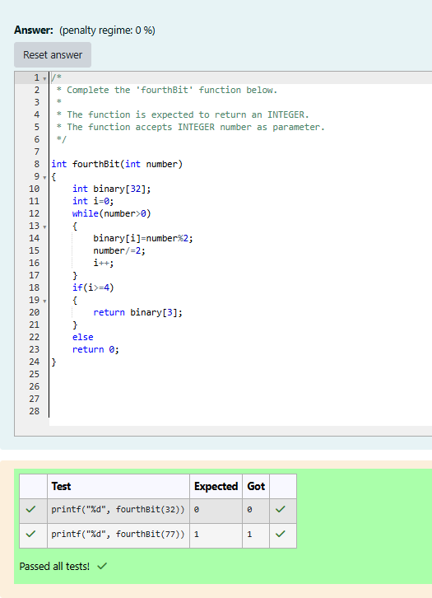

WEEK – 12 USER DEFINED FUNCTIONS REg NO : 240901065

# NAME : NETHRA P Q2)

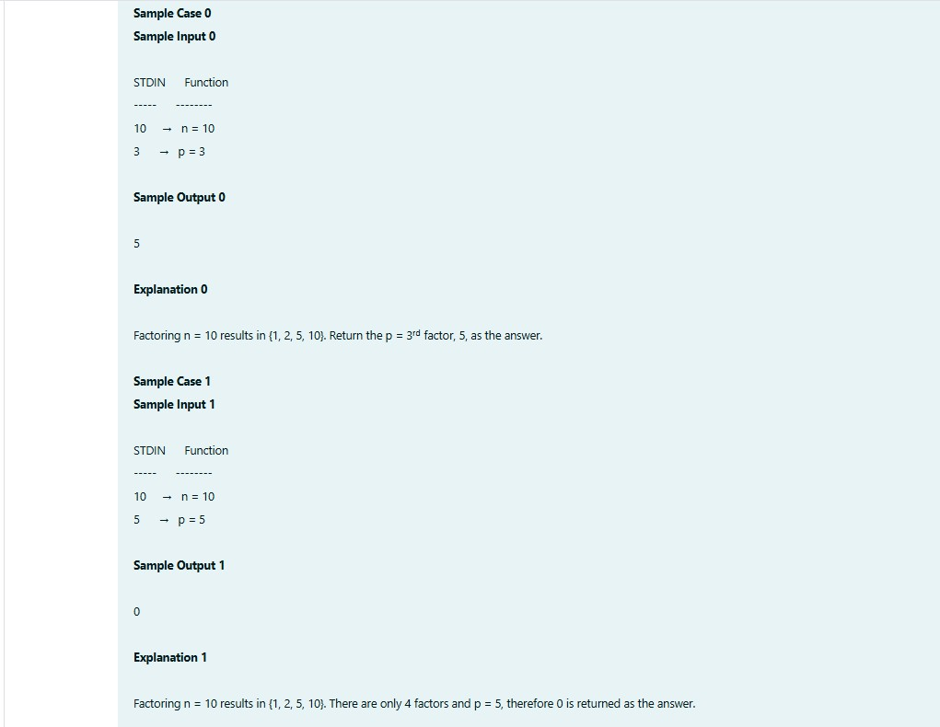

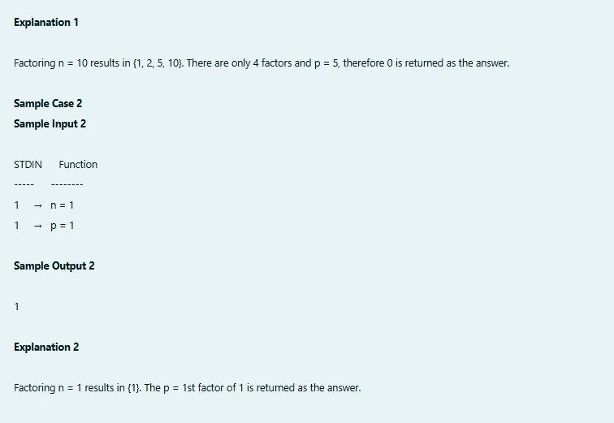

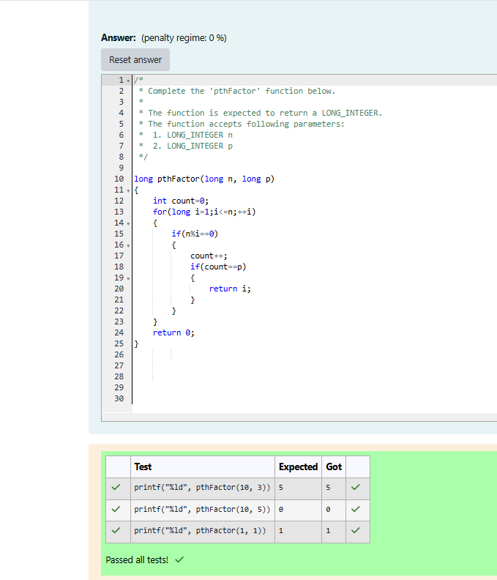

WEEK – 12 RECURSIVE FUNCTIONS REg NO : 240901065

# NAME : NETHRA P Q1)

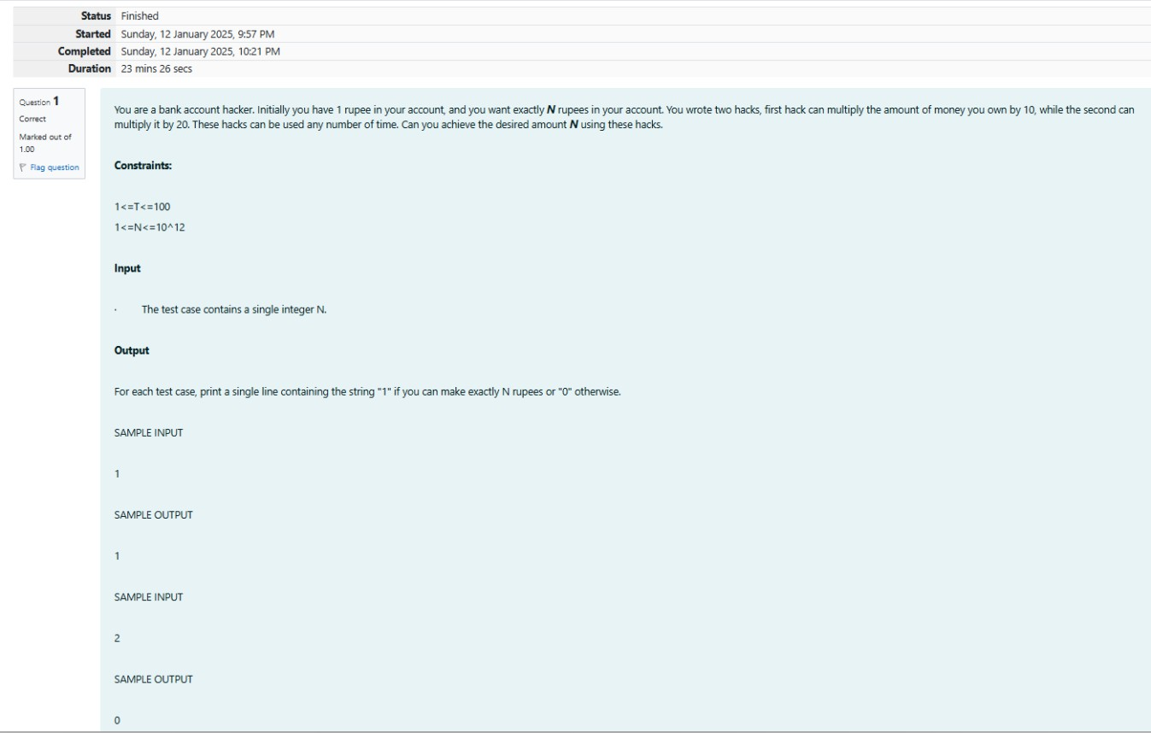

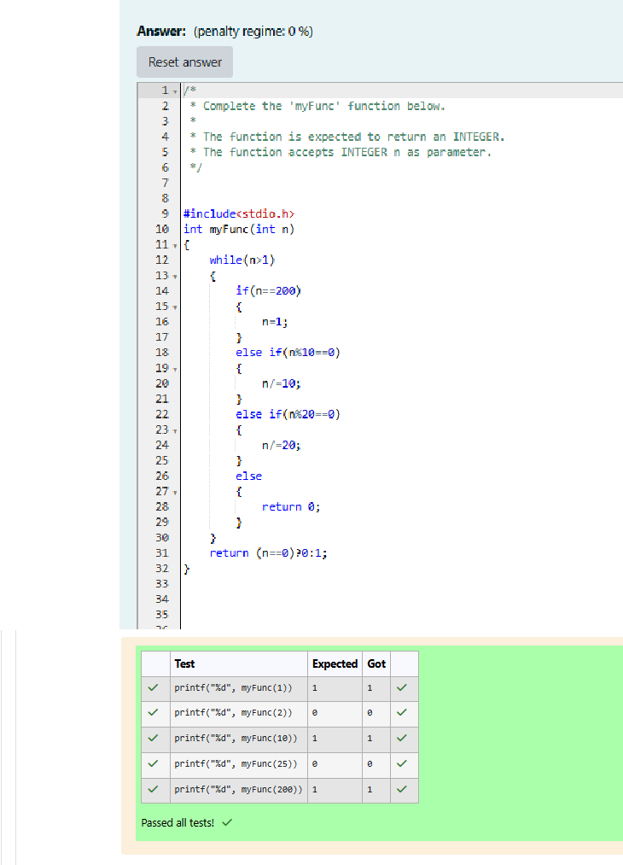

WEEK – 12 RECURSIVE FUNCTIONS REg NO : 240901065

**NAME : NETHRA P Q2)**

